Feedback Report

Instructions to Participant:
Please try to use the app with my profile without my help.
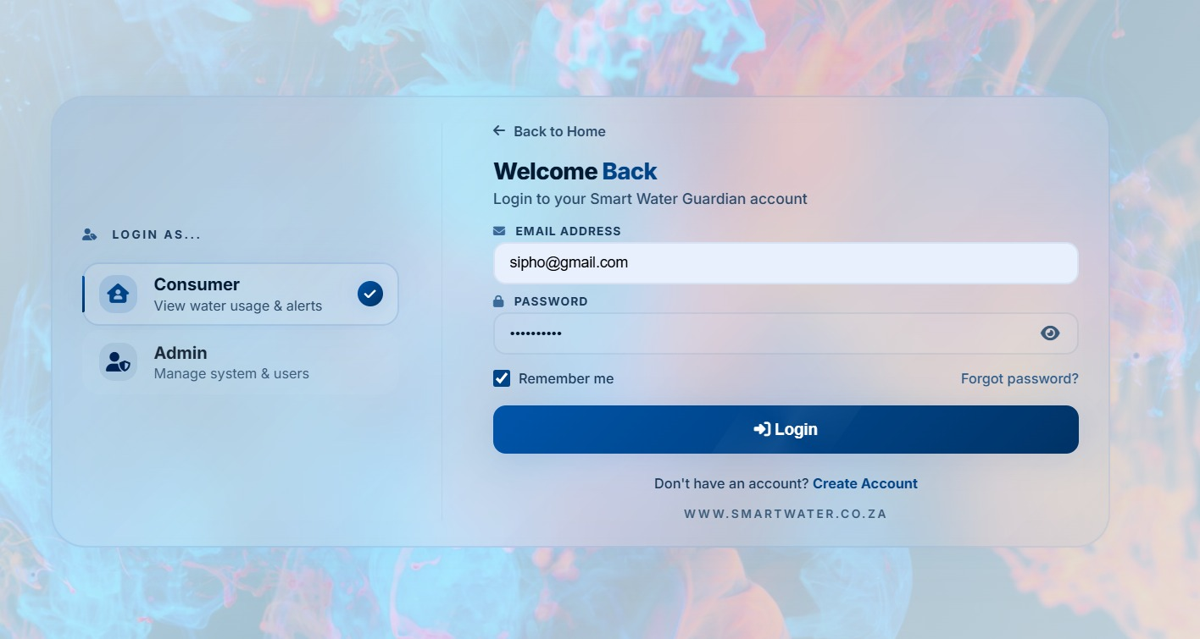
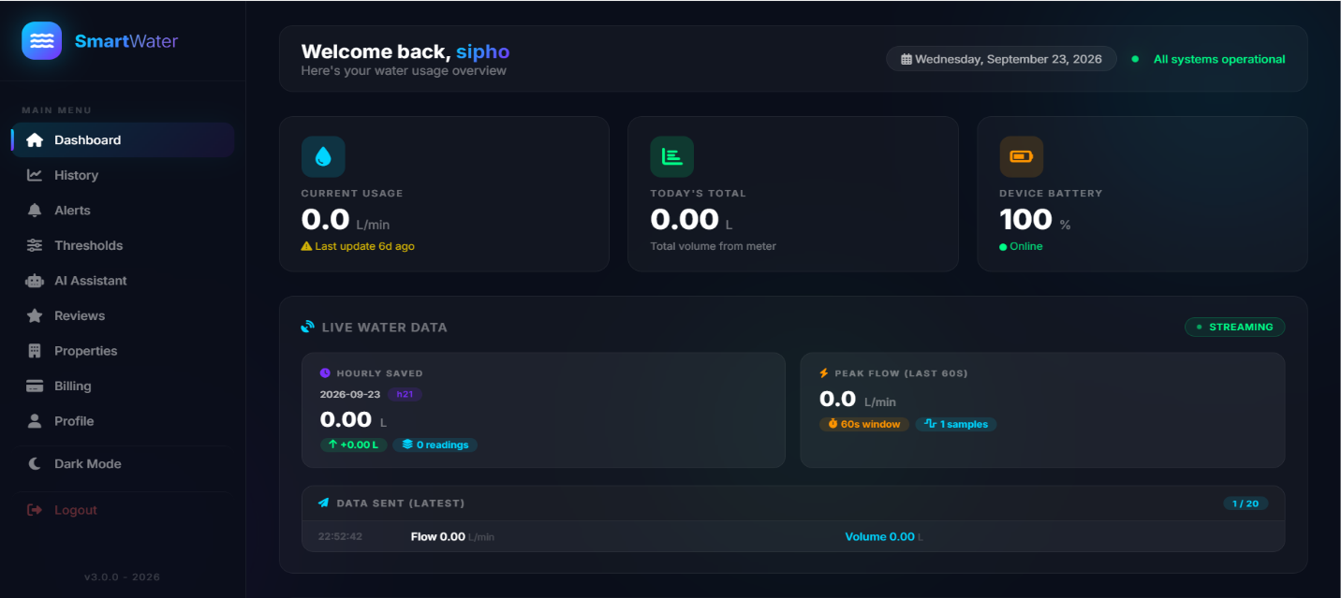
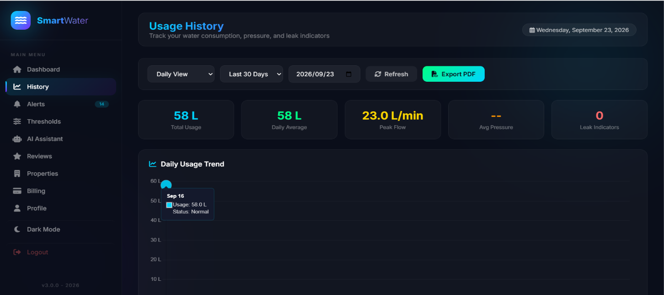

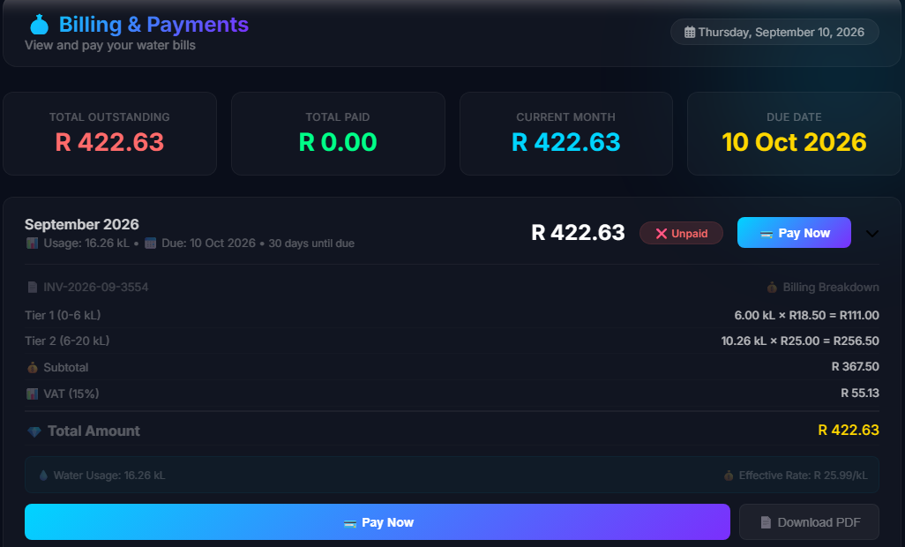
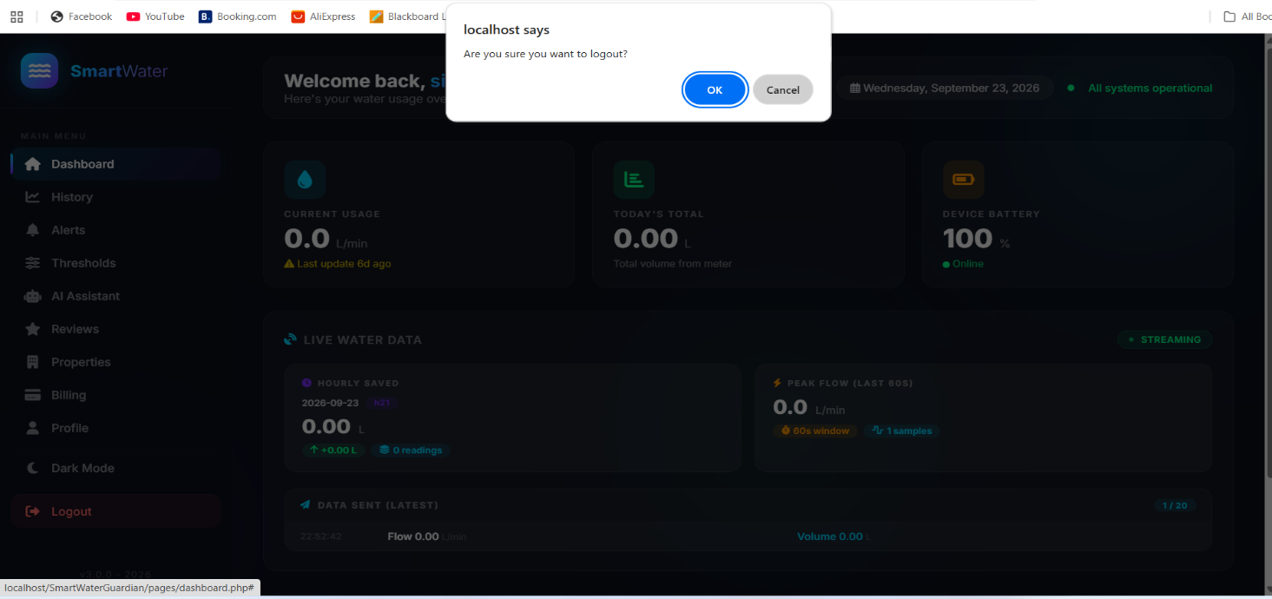
Questionnaires
1. How is the login experience?
2. On Dashboard, could you easily find and switch between hourly, daily, and monthly data?
3. Did current pressure data show immediately or did you wait a long time?
4. Could you access History and Billing pages?
5. What was your biggest frustration?
6. Any suggestions for improvement?

Participant 1 - Late 20s
Q1 Login: "The app requires me to login every time I want to use it. It works but it's tedious."
Q2 Dashboard: "Dashboard is clear. I can see current data and switch between hourly, daily, and monthly views easily."
Q3 Pressure: "Pressure data does not show immediately. I waited a long time, sometimes hours before it appeared, but when it shows it works perfectly."
Q4 Billing: "I checked billing and it's not working. Page is blank/error."
Q5 Frustration: "Pressure delay + billing not working. I saw the pressure eventually but billing never worked."
Q6 Suggestion: "Keep me logged in and fix billing. Add a loading spinner for pressure."

Participant 2 - Late 20s
Q1 Login: "Have to login every time, but login itself is okay."
Q2 Dashboard: "Hourly, daily, monthly tabs are visible and work."
Q3 Pressure: "Pressure took hours to load for me. App works perfectly once data is there, but initial wait is too long."
Q4 Billing: "Realised billing is not working when I tried to open it."
Q5 Frustration: "The wait for pressure and the broken billing."
Q6 Suggestion: "Show cached last value while loading new pressure."

Participant 3 - Early 40s
Q1 Login: "My main issue is I have to login every time I want to use the app. It should remember me."
Q2 Dashboard: "Dashboard makes sense, I can see current data."
Q3 Pressure: "Pressure was showing for me when I checked."
Q4 Billing: "Billing is not working at all."
Q5 Frustration: "Logging in every time and billing not working are my only issues."
Q6 Suggestion: "Add 'Remember Me' and fix billing page."

SUMMARY OF FINDINGS
1. Critical: Billing not working - Reported by 3/3 users (100%)
2. High: Mandatory login every session - Reported by 3/3 users, major pain for P3
3. High: Pressure data latency (hours) - Reported by 2/3 users (P1, P2) - works perfectly after loading

UI FIXES
- Fix 1: Implement persistent session / Remember Me
- Fix 2: Add loading indicator + cached pressure display
- Fix 3: Fix billing API endpoint

